.AVI Stenography Through .BMP Sequencing
Jerry Reimer, Mike Dieterle, Divine Puplampu
Department of Information Technology and Management, Illinois Institute of Technology

- Convert From .mp4 to .aviConvert From .mp4 to .avi
First, we converted an .mp4 video from our PC to .avi video with this website: https://cloudconvert.org/mp4-to-avi. The website is shown below:
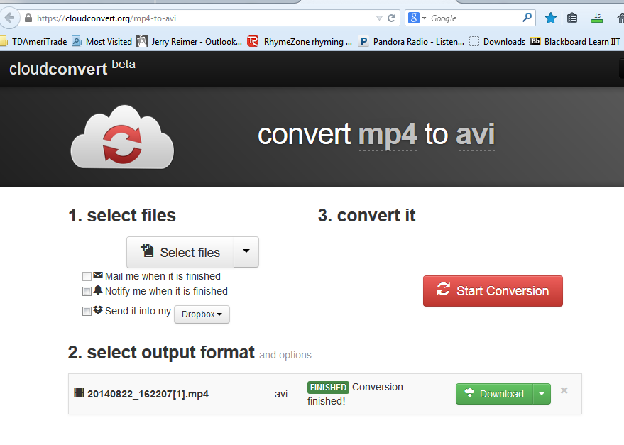

Figure 1 – Covert mp4 to avi
As shown in the images above, select a .mp4 video file to covert to .avi by clicking on “Select Files” and browsing your file system for a .mp4 video. I selected “20140822_162207.mp4”. Then, select your output format, which in our case is .avi and hit “start conversion”. Once the conversion is complete, download the .avi video from the website and save it to your system.

2. Convert .avi Video into .bmp Images
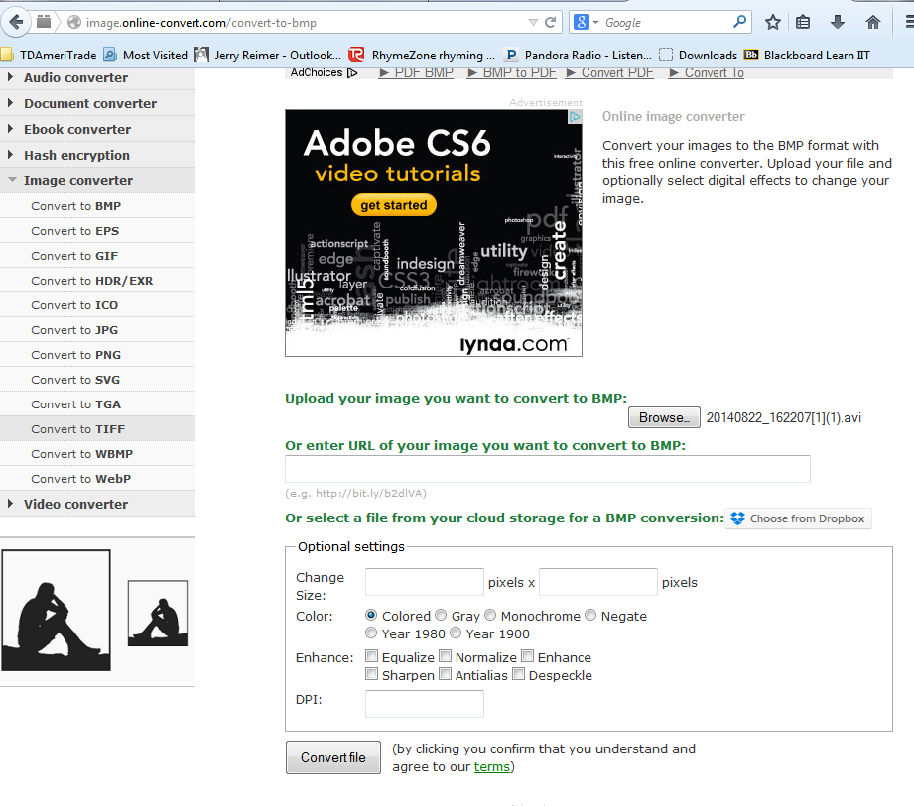
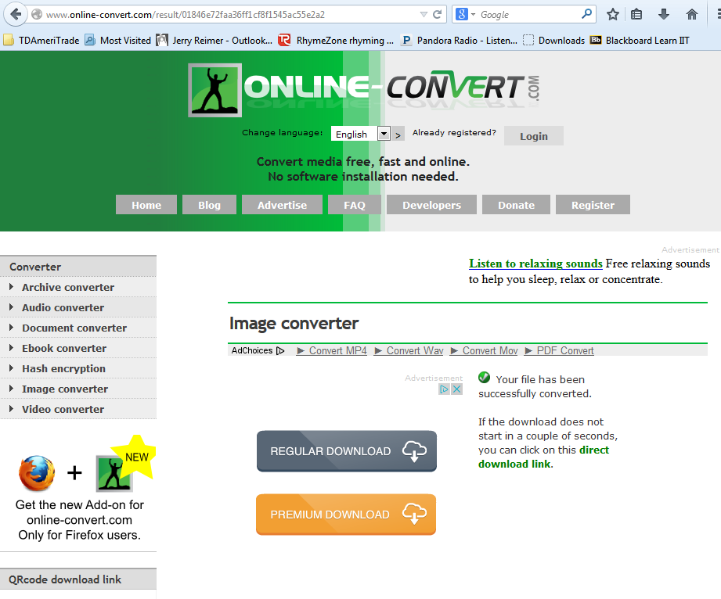
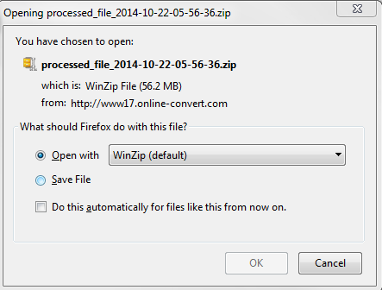

Figure 2 - Convert .avi Video into .bmp Images

Once the video was in .avi format, we broke the .avi video into a series of .bmp images with this website: http://video.online-convert.com/convert-to-bmp, shown above, by clicking the “browse” button, browsing our computer's file system, and uploaded the .avi video file. Then, you click “Covert file”. Once, the .avi video file is converted series of .bmp images, you'll be prompted to save a .zip file, like the one above, and the website will change from the highest image in figure 2 to the second highest.

3. Hide Info In .bmp Images
Once the .avi video was converted into a series of .bmp images, information can be hidden in the .bmp images. We did this by using an application called 'OurSecret', which can be downloaded here: http://securekit.net/oursecret.htm.

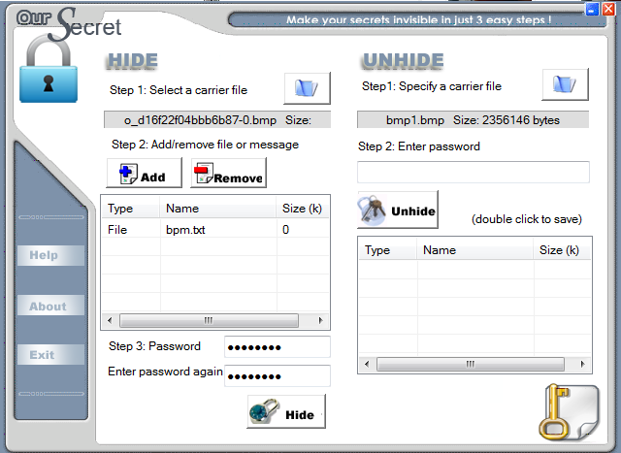

Figure 3 – OurSecret
Step 1 when using the application is to select a carrier file. In this case, we selected the 1st bpm image in the series, “o_d16f22f04bbb6b87-0.bmp”. Then, the 2nd step is to add or remove a hidden message. When you add a message in OurSecret, a pop-up window comes up and asks you to enter a new message or a file. In this case, we'll select file and hit the next button.

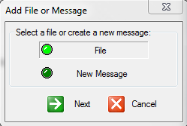
Figure 4 – OurSecret Message Insertion

The file we selected here is “bpm.txt” and it says “Let's go bears!”. Step 3 to finalize the hiding of the message within the .bmp image is to enter a password twice and select the 'Hide' icon.

4. Convert .bmp Series to .avi
Then, once the message is hidden in the image, you can recompile the video for transmission by using AVIEdit, which can be downloaded here: http://www.am-soft.ru/aviedit.html by clicking on the “setup.exe” link. Once you've downloaded AVIEdit and opened it, click on the 2nd to the left icon on the toolbar at the top of the program. The icon is highlighted in yellow in the image below.
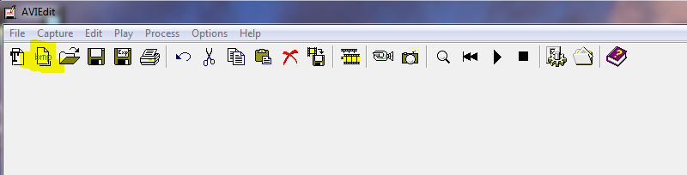

Figure 5 – AVIEdit

Once you click the icon, you can specify settings such as color depth, frames per second, frame size, and the new file name of the .avi file. You can leave these settings as is, but you can also change the if desired for different video quality.

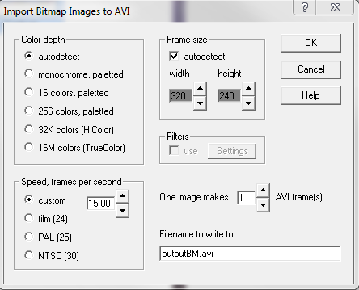
Figure 6 – AVIEdit Settings

Click “OK”. Once you click “OK”, a screen will pop up that will browse for a series of .bmp images to compile into a .avi file, as shown in the image below.
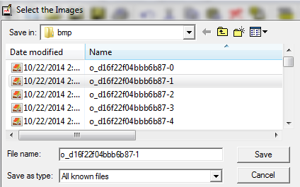
Figure 7 – .bmp Image Series Into .avi Video

Select all the images you want to include in your stream and hit “Save”. Then, another window will come up asking you for your compression scheme. I selected uncompressed, as shown below.
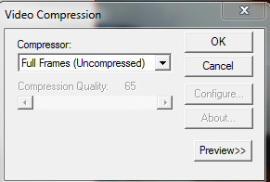
Figure 8 – .avi Video Compression Scheme

After that, you have a compiled .avi video with a hidden .txt file in it! In our case, the video is named “outputBM.avi”.
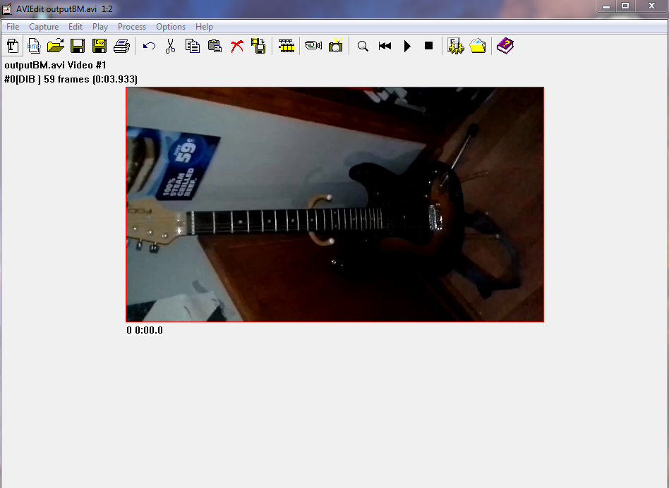

Figure 9– .avi Video with Hidden Text

You can now send the .avi video to the recipient, and the recipient can brake the .avi video down into .bmp images by using the techniques described earlier in the “Convert .avi Video Into .bmp Image Series” section.

5. Uncovering Hidden Data From .bmp Using OurSecret

Once the recipient has the specific .bmp image file that has the hidden text in it, they can browse for it in step 1 of OurSecret, as shown in the image below

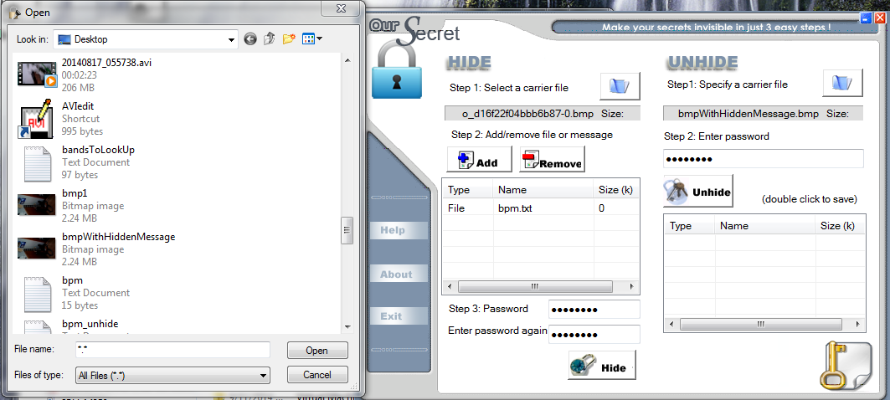
Figure 10 – .Browse for .bmp Image with Hidden Text

Then, the recipient enters the same password that the sender used when hiding the message and click unhide, and the hidden message will appear in the table, as shown below.

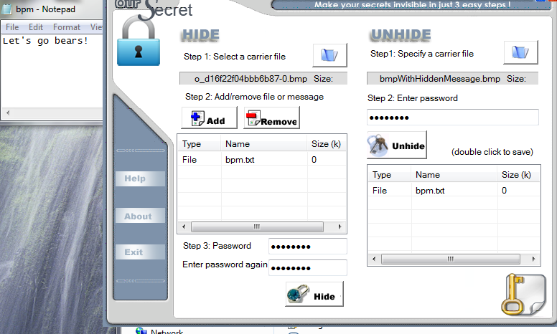

Figure 11 – Hidden Message Recovered from .bmp Image

6. Conclusion
Through the use of online tools, AVIEdit & OurSecret, one is able to hide messages in .bmp images which can be compiled into .avi videos for transmission to recipients.

